PyTomGUI for processing of cryo-Electron Tomograms

Gijs van der Schot, Laura van Bezouwen & Friedrich Forster

V2.0 (August 2019)

# Introduction

The aim of this tutorial is to introduce you to the computational workflow in cryo-electron tomography (Cryo-ET). Cryo-ET is an imaging technique used to obtain high-resolution three-dimensional images of biological objects such as macromolecules and cells in their near native environment. Samples are tilted as they are imaged, resulting is a set of 2D images (tilt series), that can be combined to form a 3D reconstruction. In Cryo-ET samples are immobilized in vitreous ice (imaged at temperatures below -160 °C) allowing them to be imaged without dehydration or chemical fixation, processes which could disrupt or distort biological structures.



**Figure 1**. Schematic of the electron tomography setup. The sample is tilted between -60° and +60°. The recorded Tilt-series images are combined into a tomographic reconstruction. From: Eikos, Own work, CC BY-SA 4.0, <https://commons.wikimedia.org/w/index.php?curid=45403034>.

This tutorial consists of two parts. In the first part a tomogram reconstruction is discussed and in the second part sub-tomogram averaging will be explained.

In the first part of the tutorial you will reconstruct several three-dimensional tomograms from measured tilt series. Using quantitative measures such as Fourier Shell Correlation (FSC) the resolution of a raw tomogram barely exceeds 50 Å – nevertheless, much higher resolution information will be present in your tomograms, but difficult to distinguish from the background – if you squint you tend to see quite some detail beyond this level. Larger macromolecular complexes can be identified visually in tomograms.

The limit on the resolution of the tomographic reconstruction is due to the maximal dose the sample tolerates. In order to extend the resolution, identical parts of the tomogram can be averaged. This is called subtomogram averaging. Resolutions beyond 4 Å have been achieved this way [Schur et al 2016]. In the second part of the tutorial you will select regions of interest within a reconstructed tomogram, and you will align the sub-tomograms to obtain a higher resolution structure of the object of interest. In many cases, the sub-tomograms will be structurally heterogeneous because they correspond to different states of the molecule under scrutiny. Finally, you will ‘classify’ the subtomograms into structurally more homogeneous bins, allowing you to analyze major structural differences in the data.

# Installation and starting the PyTomGUI

PyTomGUI is currently available as a beta version, which works largely stably in our lab. PyTom and the PyTomGUI have been tested on LINUX and Mac. The open source code and installation instructions are found on:

<https://github.org/FridoF/PyTomGUI>

Documentation can be found at:

<http://strubi.chem.uu.nl/pytom>

The PyTomGUI on the ANGSTROM cluster of Utrecht University needs several modules before the program can run. To start execute the following lines in the terminal:

module load openmpi/2.1.1

module load python3/3.7

module load lib64/append

module load imod/4.10.25

module load motioncor2/1.2.1

module load pytom/dev/gui_beta

Start the gui by executing:

pytomGUI.py

In later versions of PyTomGUI it is possible that another version of one of the modules is needed. Just unload the module (command: module unload -program-) and load the module with the correct version.

# Data transfer

In this tutorial we will process four tilt series that are described in Khoshouei et al, *Journal of Structural Biology 2016.* The sample in the tilt series are purified mammalian 80S ribosomes. The data were recorded using SerielEM on a K2 detector in counting mode, using a VPP to improve contrast*.*

The tilt series can be downloaded from the EMDB under accession code EMPIAR-10064. Make sure you only download the tilt series recorded with a volta phase plate (VPP). The four tilt series are downloaded as mrc-stacks, which is not a default datatype of the PyTomGUI. In order for PyTomGUI to be able to incorporate the tilt series, each tilt image has to be saved as a mrc file. Furthermore, a meta file has to be generated. In the tutorial folder you find a script named **mrcs2mrc.py** that helps you with this. Please run the script as follows for each of the downloaded files:

pytom [PATH_TUTORIAL]/mrcs2mrc.py -f [STACK_NAME] -t [TARGET_DIRECTORY]

In the target directory you will find a meta file (in mdoc format) as well. Please remember this directory as we will use it in the next step.

## Starting a new project

Once the GUI is running you can choose to open an existing project or to open a new project. In this case we will start a new project.

Click on Project

Click on New

A popup screen will show and will ask for a project name as well as were to save it

Give the project a name, for instance pytom_practice

Click Browse

In the popup screen you will end up with a line saying: /data/username/projectname

Press Create

The GUI will now pop up. From this screen we will continue working. There are two panels, the left panel which is the main panel. In here you can select which step you would like to do. The right panel is where the steps are performed.

Any time you can press Save in upper bar and close the program. Once that is done, you can continue at a later moment.

## Collect data

The data is already collected but needs to be imported into your own project folder to be able to process it. The data that we are going to process contains four tilt series. We will process the tomograms as much as possible in one go. Therefore, we are using Batch-tab and not the Individual Assessment-tab. In future projects where you would like to examine only one tomogram then you can click Individual Assessment and follow those steps. All steps are the same, between the two options.

Click on Data Transfer

In the right panel two tabs will show, “Individual Assessment” and “Batch”. This data set contains more than one tomogram and therefore we use “Batch”.

Click on Batch

Activate Collect Data

The data for this tutorial is placed in a general place. For both the Nanograph folder and the Mdoc folder the path is the same.

Press Browse

Go to the folder where you have saved the individual VPP tilt images.

Press open

Press Run

With Run the data is imported to your own project folder. This takes a few seconds. In the bottom of the screen there is a bar showing the percentage of the data that is imported. Once that is finished you can continue.

As the data for this tutorial is already motion corrected we will not have to do motion correction. Please follow another tutorial if you are interested to learn how to do this step.

# Tomographic Reconstruction

We have successful transferred the data into our project folder and applied the motion correction. The next step is tomographic reconstruction of the data. Therefore, we need to activate the Tomographic reconstruction page in the left panel.

Click on Enable Stage

Click on Tomographic Reconstruction

In the left panel the second button is now activated

## Select tomogram

During this step the tilt images will be squared. K2 images have a small difference in the x and y dimensions. Furthermore, pixels with extreme values will be corrected to the mean value and the data are copied to separate folders. The tomogram names will start from _000 on.

Click Select tomograms

Press Refresh Tab

Now a table with the four tilt will become visible. Please check all four boxes under run. You can do this by clicking all checkboxes individually, or by checking the box in the run column in to top row, indicated by “Apply to All”. After checking the boxes the putative name of the tomogram is filled in automatically.

In the fourth column labelled by ‘input files’, one can select the folder where the tilt series is saved. As we will start from data that is already motion correted, our data will be in “Raw Nanographs” instead of “Motion Corrected”.

Select by input files: Raw Nanographs

Press Run

It takes a few minutes before all the folders are made. In the terminal there is a message saying RuntimeWarning: Map ID string not found – not an MRC file, or file is corrupt. You can ignore this message. One can follow the progress of this step in the progress bar.

## Create Markerfile

The rough alignment of individual tilt images is known from the experiment, but that is not sufficiently accurate for a meaningful reconstruction. Thus, we need to correct for differences in rotation, translation, and magnification between individual tilt images. For this we have added gold particles (fiducials) to our sample. They form points of reference in each tilt image. The aim of this step is to trace their relative position in each of the tilt images. You have to track at least five gold particles that are present in each tilt image.

Open Settings

Select a tomogram name

Change Binning Factor Reading 4

Change Binning Factor Finding Fiducials 12

Press Load Tilt Images

There are more parameters present in the Settings window, Angle tilt Axis (degrees), Reference Frame, Pixel Size (Å), Fiducial Size (Å). Those are filled in automatically based on the specifications in *meta* file.

Recommended parameters for Binning Factor Reading and Binning Factor Finding Fuducials are 4 and 8 or 12, respectively. Good starting values for Accuracy level and Threshold cc_map are normal and 1.75.

In the coming steps you will select the markers that you can use for tilt alignment. In case the markers are not selected as hoped, it can be wise to play around with the Fiducial Size and the Threshold cc_map.

Once the images are loaded you can navigate through the display of the tilt images with some hotkeys (see Figure 1).

**1**: Go to tilt image smallest tilt angle.

**2**: Go to tilt middle tilt image.

**3**: Go to tilt image largest tilt angle.

**F:** Find fiducials.

**D**: Determine frame shifts.

**I**: Index fiducials.

**M**: Manually adjust marker sets (see figure 2).

🡨 : go to previous tilt image.

🡪: Go to next tilt image.

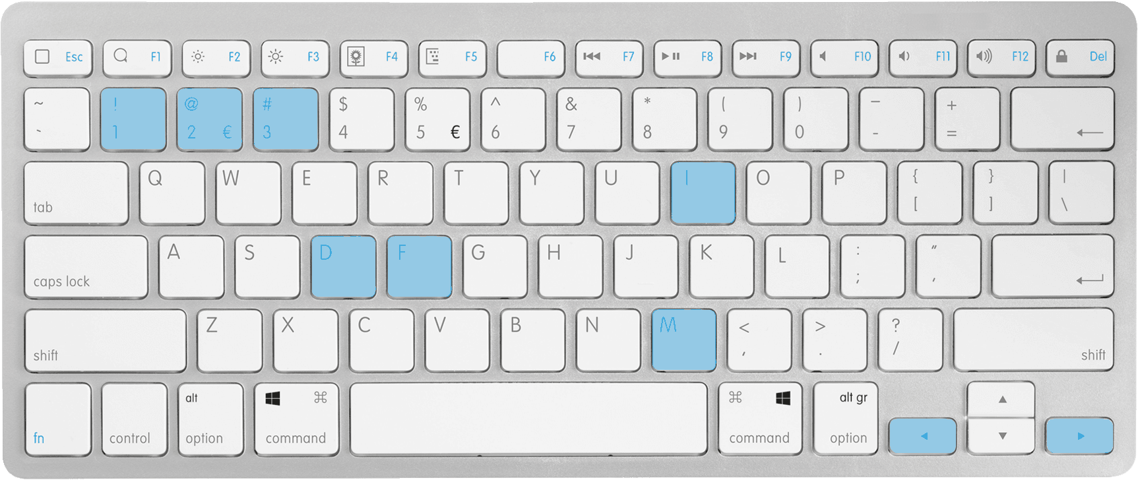

Figure 1: General hotkeys for fiducial assignment.

The next step would be to find all the fiducials and create a marker file. The Find Fiducial step influence the other steps. Depending on the Accuracy level and the Threshold cc_map more or less fiducials are found as well as false positive or false negatives. Gold beats can easily be detected by eye, and the found fiducials should match. Changing the threshold could give more or less fiducials. Once the threshold is set you can continue with the other steps.

Click Find Fiducials (or press F)

With the on forehand selected accuracy level the fiducials are detected in the tomogram

Click Detect Frame Shifts (or press D)

To determine the frame shift between images, based on the found markers

Click Index Fiducials (or press I)

Automatically a set of fiducials is created. This step can take really long. Therefore it is advised that before you start indexing all fiducials, in the reference image you remove the markers that you won’t use at all. This can be done by removing with the right mouse button in the small screen.

When Index Fiducials is finished, colored numbers are displayed next to the markers, which are indexed with confidence. For some of the markers the indexing will not succeed for all tilt angles. And in rare cases, the indexing might even jump from one marker to another. Both can be fixed by a manual intervention: Manually adjust Markers.

Click Manually adjust Markers (or press M)

When pressing M or selecting a marker in Adjust marker window, the hotkeys change. Pressing M again, or clicking deselect marker in the Adjust marker window, the normal hotkeys will be restored. Figure 2 shows the new hotkeys.

**0-9**: Select the marker ID of the marker you want to adjust.

**-** and **+**: Decrease/increase the marker index by 1.

**M**: Toggle between general hotkeys and manually adjust marker related hotkeys (see figure 1).

**>** or **<**: Find tilt image with missing marker in tilt image with higher/lower tilt angle.

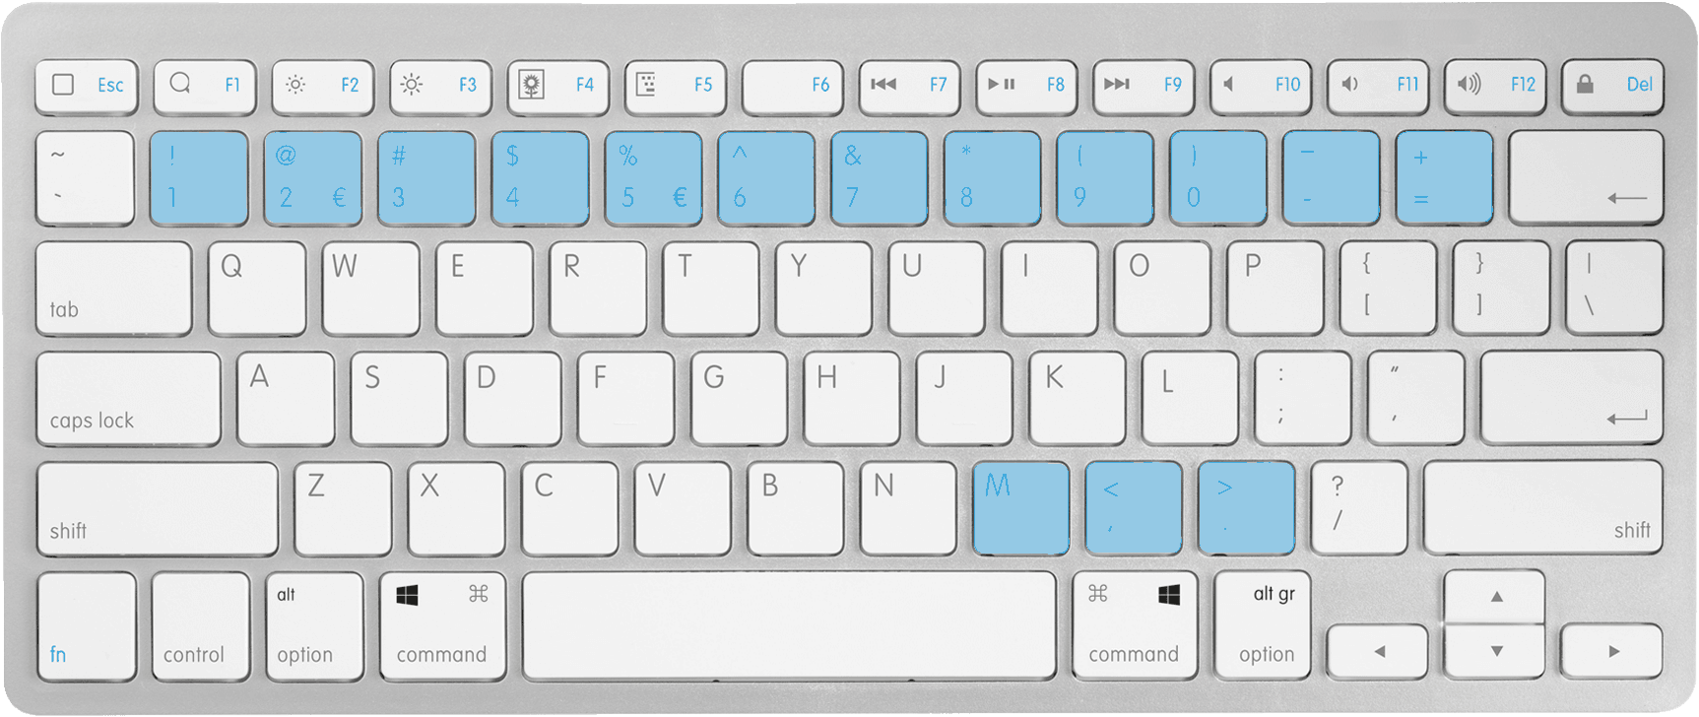

Figure 2: Hotkeys for manually adjusting marker sets.

Remove with the right mouse button all the markers that are not correct, or not indexed with confident. Those markers have a red circle, instead of a blue circle.

Select/Deselect Markers

Select the marker that you want to use. Toggle between the screens to see where you have to select the fiducials. In the small screen, the manual pick fiducials, select the fiducial. Do this for all markers which you want to adjust.

Add/Remove Markers

Next/Previous Missing Markers (press < or >)

Once the fiducials are adjusted

Press Index Fiducials (or press I)

The fiducials are re-indexed, and it could be that the numbers are changed of the markers. Repeat this process till you are satisfied with the indexing. The last step would be to create the file where all markers are in saved.

Press Create Marker file

Select the markers that you would like and move them over to the selected marker sets

Press Save Markers

The markers will be saved in a file markerfile.em in the sorted folder of the respective tomogram. The coordinates are determined coarsely in the binned images. These positions can be refined in the unbinned images using Recenter Markers and finally save them again.

Repeat for all tomograms

Note: If you do not want to use the fiducial localization from PyTomGUI you do not have to. In principle, everything required for the PyTom workflow is a file that contains the (indexed) marker coordinates. The underlying PyTom alignment functions also accept IMOD-generated wimp files instead of the pytom-generic markerfile.txt format. You can also load these marker coordinates into the PyTomGUI when you load a WIMP markerfile in the Create Markerfile menu – PyTom also supports this format in addition to its native markerfile.em format. Alternatively, you can also use matlab function av3_wimp2em.m for conversion.

## Alignment

After the creation of a markerfile, the image transformations need to be applied to the tilt images. This is done in the alignment step. In this step the aligned tilt images are created. These images will be used during CTF correction. To start the alignment

Click Alignment

Click Batch Alignment

Press Refresh Tab

Now a whole list of all the tomograms will occur.

Select the tomograms that you would like to create

In this case you will use all four tomograms. You don’t need to change anything of the parameters. All parameters are read in from previous files

Press Run

It will take a few minutes before all the

After the creation of a markerfile, one can apply the image transformations to the tilt images. For the eventual high-resolution reconstructions, it is handy to generate the unbinned, aligned tilt images, which are created in this step. To this end we activate the *Alignment* panel and choose *Batch Alignment* to process all tomograms from the project. Clicking *Refresh Tab* should show all available tomograms. Select the folder where your sorted tilt images are ([PROJECTDIR]/03_Tomographic_Reconstruction/tomogram_???/sorted/), together with the respective metafile (located in the same folder). Check the *sbatch* box to submit the job to the queue or *Run* locally.

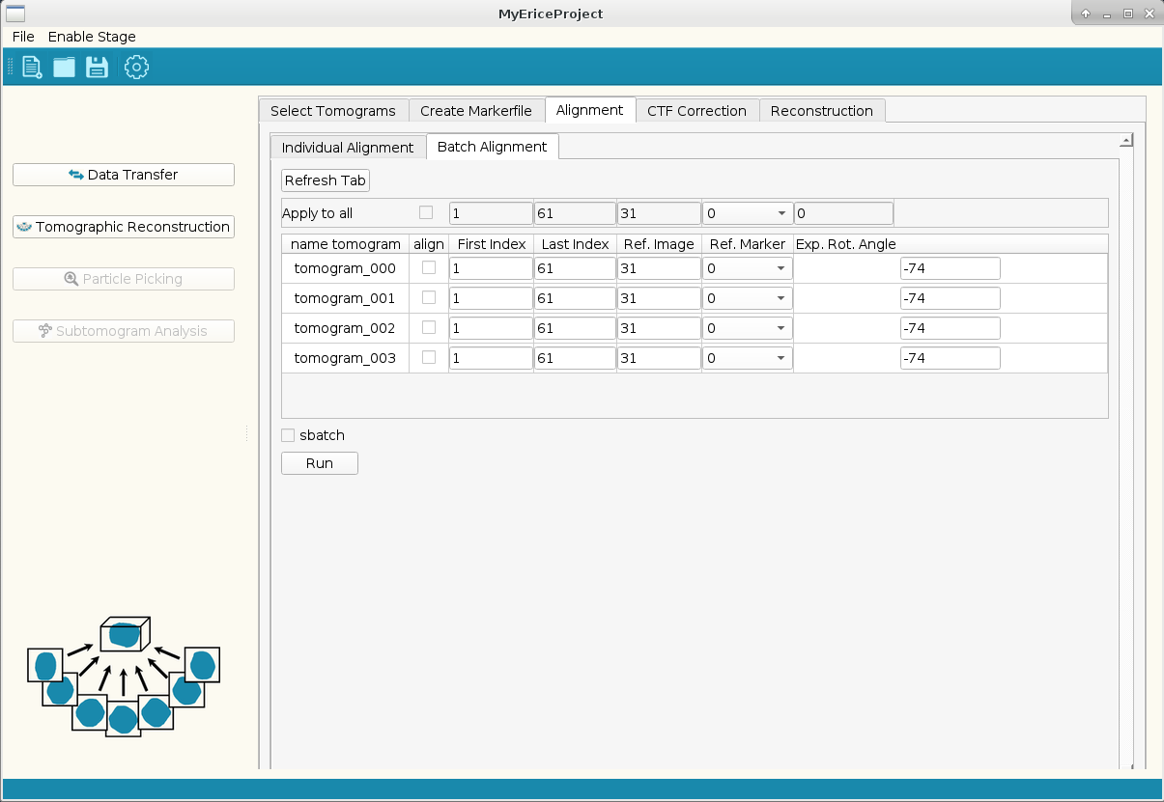

**Figure 5**. Transform alignment parameters to tilt series and write to disk.

## CTF Correction

As the tilt images are recorded in focus, we do not have to do CTF correction.

## Reconstruction

After creation of the markerfile we compute overview reconstructions. PyTom supports two types of 3D reconstruction: weighted backprojection (WBP) and Iterative Nonuniform Fourier Reconstruction (INFR). WBP comes with two different weighting schemes: r*-weighting, which linearly enhances weights with increasing frequency, and a scheme which accounts for the precise angular sampling (going back to Harausz and van Heel). The former typically results in over-amplification of high-frequency noise, which is reduced with the alternative weighting scheme. The iterative INFR can achieve more accurate weighting and reconstruction at the expense of computation time.

Under the *Reconstruction* tab you can choose *Batch Reconstruction* to reconstruct an entire set of tomograms using specified parameters (Figure 9). This mode support WBP (precise angular sampling) and INFR. The choice of the reference marker determines the coordinate system for the final reconstruction, as also the case for tilt series alignment. We typically use a *Bin Factor* of 8 for overview reconstructions. If *sbatch* is checked, the reconstruction will be submitted to the slurm queue.

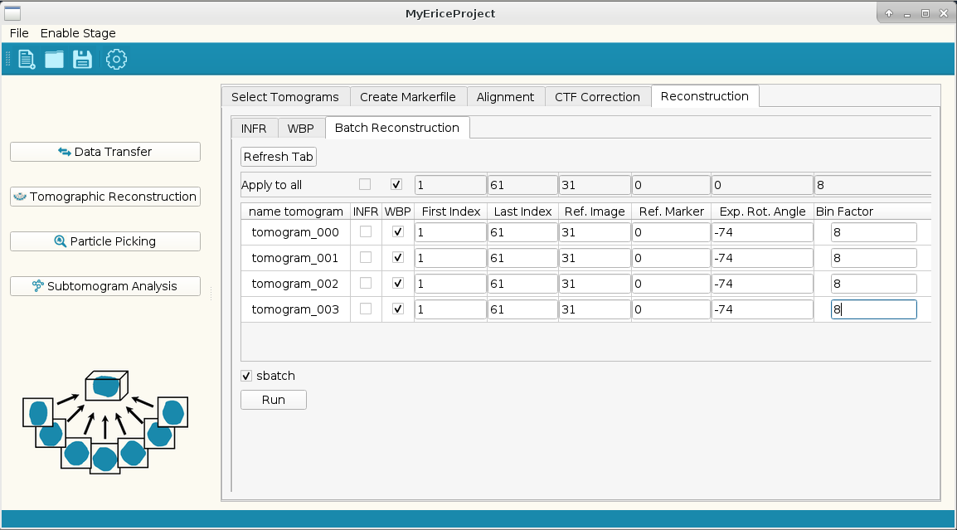

**Figure 9**. Reconstruction of tomograms. Make sure that Ref. Marker is the same as for the unbinned aligned images created previously (in this case marker 0).

# Particle Picking

The next step of the processing workflow is to determine the coordinates of potentially interesting features, typically particles of a specific type. There are two options supported to obtain these coordinates: particle coordinates can be determined manually or automatically using template matching.

## Manual Picking

Manual picking of particles is a good option to avoid possible bias due to external references. A typical task can be to localize some particles manually, to create a first subtomogram average from these particles, which may then serve as a reference for further exhaustive searching of tomograms and again subtomogram averaging and even classification.

To start manual picking you enable the stage *Particle Picking*. Then you choose the panel *Manual Picking* (Figure 10) where you can load tomograms and pick particles interactively.

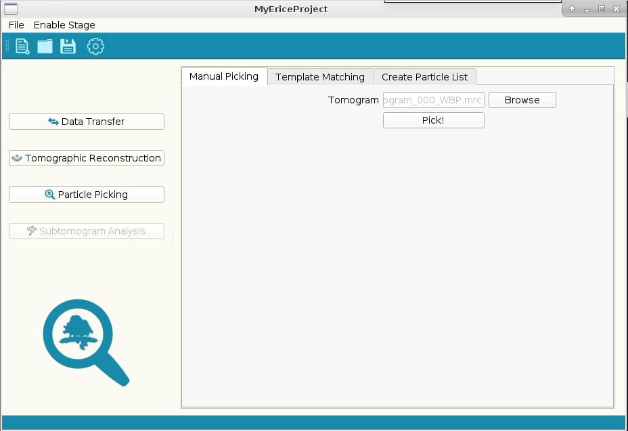

**Figure 10**. Manual picking panel. *Browse* allows choosing an overview tomogram and *Pick* will open an interactive display window for manually marking particles.

An interactive viewer allows marking features with the mouse in 2D xy-slices (Figure 11). The 3D coordinates can be stored in a file for further processing. The determined coordinates are be saved in ascii (.*txt*) files.



**Figure 11**. Viewer for selecting particles. To enhance contrast a *Gaussian Filter* can be applied. The *Size Selection* specifies the diameter of your particles (in pixels) and hence the displayed circles. *Step Size* specifies the number of z-slices to be moved upon pressing the arrow buttons.

PyTom internally works with ParticleLists. These are xml files that not only contain particle locations, but also their orientations, fine shifts and other useful information like filenames and missing wedge. To convert the coordinate list into a particleList you choose the *Create Particle List* panel and the *Single* mode, which allows you to create a particleList with a coordinate file as input (Figure 12). Best stick with the suggested filenames for the (unbinned) Subtomograms, which you will the reconstruct in the *Subtomogram Analysis* stage. Randomization of the orientation of the particles in the coordinate files is recommended, as the default angle of the particle is set to 0,0,0. Having all particles in the same orientation might cause artefacts in further processing steps.

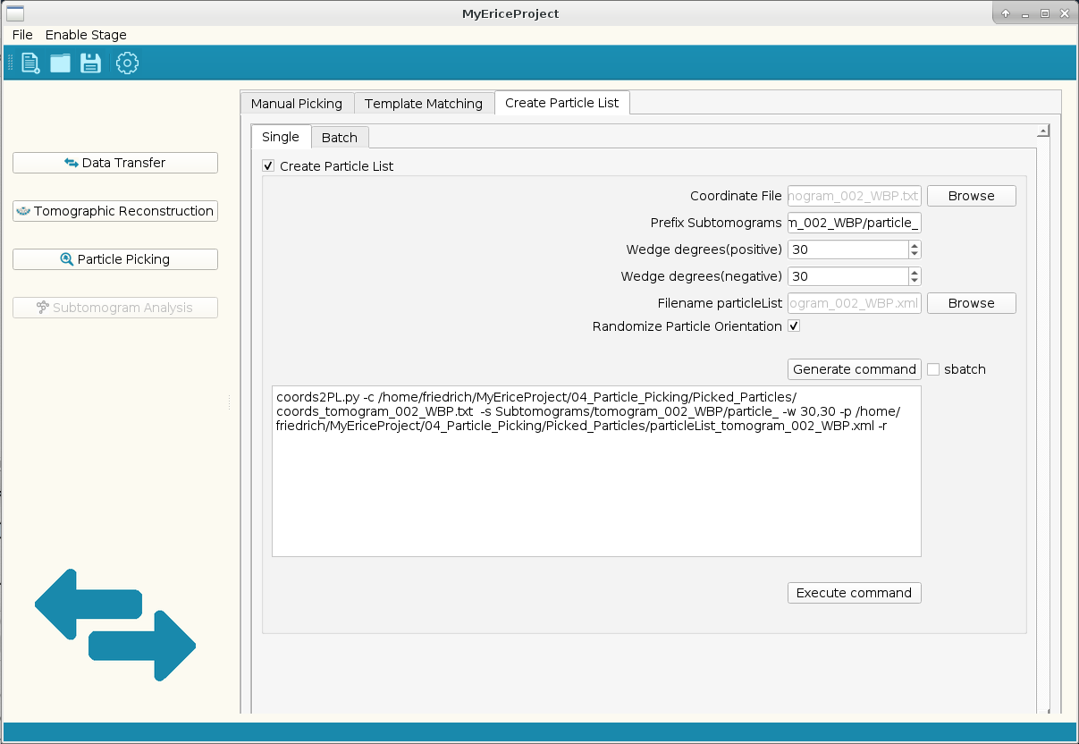

**Figure 12**. Converting a single coordinate list to a particleList.

Several coordinate lists and respective tomograms are combined into a single unified particleList using the *Batch* option (Figure 13). The resulting particleList then contains particles from different tomograms.

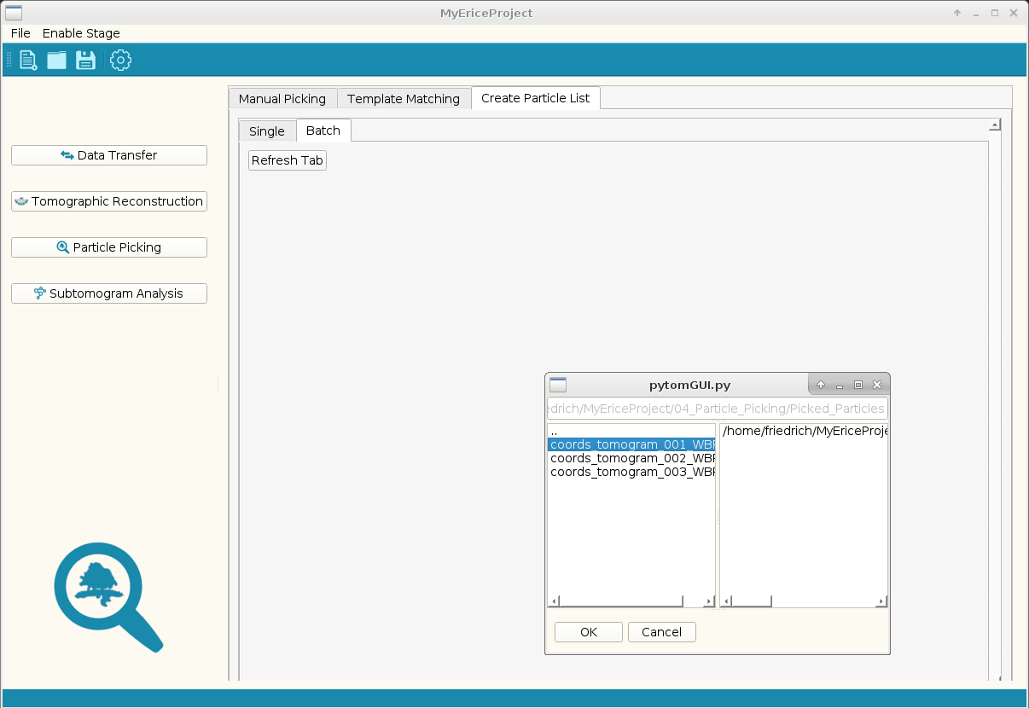

**Figure 13**. Converting coordinates to particleLists in Batch. Upon clicking the *Refresh Tab*, a dialog window will open. In there you need to double-click on coordinate files to add them to the list of processed coordinate files on the right. Pressing *OK* will invoke Figure 14.

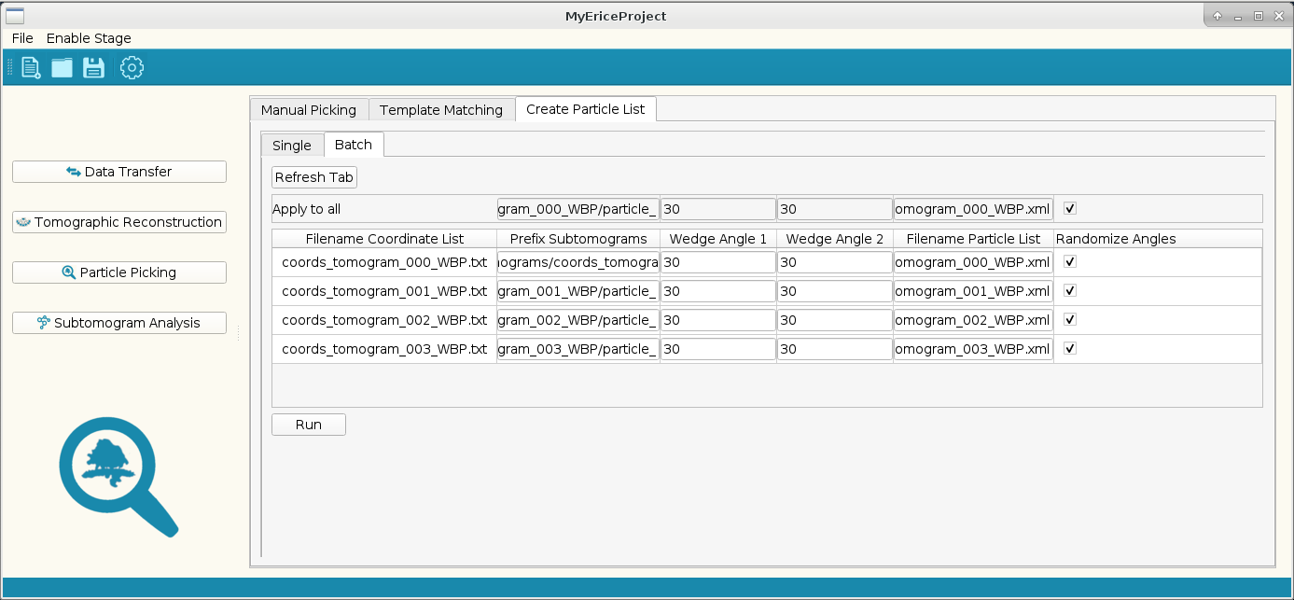

**Figure 14**. Continuation of converting coordinates to particleLists in Batch.

## Template matching

Open the *Batch* panel in *Template Matching*. Clicking *Refresh Tab* will open a dialog window, which first asks for Tomograms (double clicking adds a tomogram to the selection!), then template(s), and finally mask(s) to be used in the batch processing. In the tutorial data folder, you find a folder templates with a ribosome template (21 Å voxel size, corresponding to the 8x-downsampled overview reconstruction) and a corresponding spherical mask.

You can specify the parameters in the window that appears after the dialog window (Figure 15). For example, *Angle List* is a list of predefined Euler angles to be probed. Its angular increment and the total number of orientations characterize the respective lists (e.g., angles_12.85_7112.em samples 7112 orientations with 12.85 deg increment).



**Figure** **15**. Template Matching in *Batch* mode. This window displays after tomograms, template(s) and mask(s) have been specified in a dialog window. The Run column is used to select the tomograms for which the user wants to run template matching, using the template and sphere mask as they are. The Mirrored column will run template matching using the automatically generated mirrored version of the template or spheremask. *Start Z* and *End Z* are used to select a section of the tomogram.

Templating matching correlates the tomograms with the template, confined to a mask. The template has a much smaller dimension than the tomogram, but the same pixelsize after binning, and the mask has to be of the same dimension as the template. EM and mrc files are accepted as input. Maxima of the resulting correlation volume specify likely particle localization. To determine coordinates of maxima of the correlation volume and the corresponding orientations that yielded the highest correlation scores the corresponding output files need to be analyzed using the *Extract Candidates* box (Figure 16).

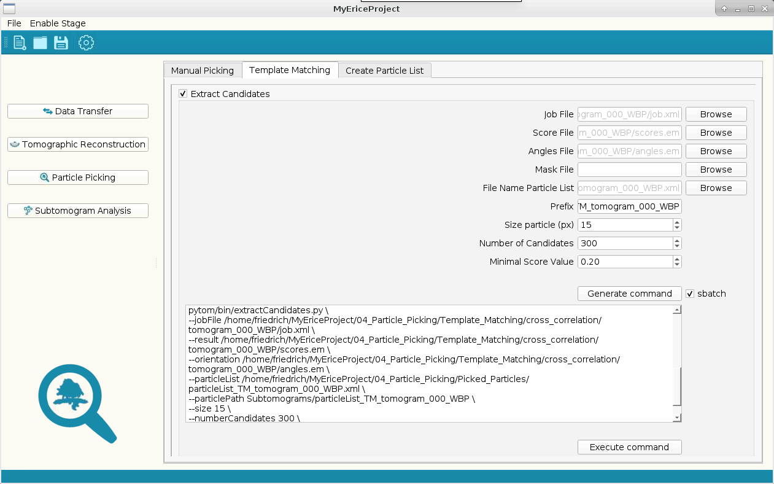

**Figure 16**. Determining coordinates and orientations of putative particles. Choose the *Job File* from the template matching run in the dialog invoked by *Browse*, which fills *File Name Particle List* and *Prefix* (names of subtomograms) automatically. In this case, coordinates and orientations for the top 300 hits will be stored (if above a correlation coefficient of 0.2). *Size particle* is important to prevent particles from being picked twice. This radius should correspond to the diameter of the particle.

The underlying extraction scripts requires the input parameters of the template matching run. The *Job, Score and Angles File* are found in the folder [myProject]/04_Particle_Picking/Template_Matching/cross_correlation/tomogram_xxx_WBP/. The Mask File is optional to restrict the search to specific areas of interest.

The individual particleLists can be combined into a single one using the batch mode of Create Particle List.

Press refresh tab

In a dialog window the respective particle lists (xml format) and/or coordinate files (txt format) are selected.

Press OK

A new table appears with several columns. The tilt angle colums sets the angle between the -90 deg and the tilt angles of the first tilt image. Tilt angle 2 determines the angle between the tilt image with the highest tilt angle and +90 deg. The final column is used to set the orientation of the particles. It is recommended to randomize tilt angles for coordinate files with manually selected particles.

Press *Run*

The GUI will ask for a file name of the combined list, and in which folder you want to store this file. We recommend [PROJECT DIR]/04_Particle_Picking/Picked_Particles or a subfolder in this folder.

5.3 Removal of wrongly assigned particles

Every selection contains falsely annotated particles. Having a significant fraction of outliers in your selection might hinder further processing steps, so it is necessary to clean up your initial selection list. The GUI can be used in several ways to deselect particles. In this tutorial we will use two methods for cleaning up the particle lists. The first procedure can be done at this stage, and the second can be done at a later stage.

Go back to the *Manual Picking* tab, open an individual tomogram, and load the respective particle list by clicking on the load icon (select **particle list** instead of **coordinate file** in file type menu). Please note that loading a particle list takes a bit of time. After opening the particle list, the selection window is populated with images of the selected particles. By examining these images, you can visually spot outliers. An example of an outlier can be seen in Figure XX. Right-clicking on the images of outliers will deselect them.

Another feature you will use is the lower threshold for the cross-correlation coefficient. By left-click on a particle, its correlation coefficient of particle picking will show in the title bar of the window. By setting the lower threshold to the correlation coefficient value above which most particles are particles of interest, you can at once deselect all particles with a lower coefficient. This coefficient often roughly correlates to the inflection point in the large drop off in figure XX.

After deselection click the save icon and give the new particle list an appropriate name. Please leave tomogram_XXX_WBP in the title. Once you have completed this step for all four particle lists, please combine them into a single particle list (as described above). In total you should have at least 1400 particles.

Now we are ready for subtomogram analysis.

Click Enable Stage

Click Subtomogram Analysis

# Subtomogram Analysis

## Reconstruct Subtomograms

First you need to reconstruct the subtomograms corresponding to the coordinates specified in the respective particleList. After enabling the stage *Subtomogram Analysis* you select *Reconstruct Subtomograms*, and therein *Batch Reconstruction* to reconstruct particles from combined particle list, or several individual particle lists. For the reconstruction you now make use of the particle list from which you removed the obviously wrongly-assigned particles. Please use a binning factor of **2** to speed up the next steps.

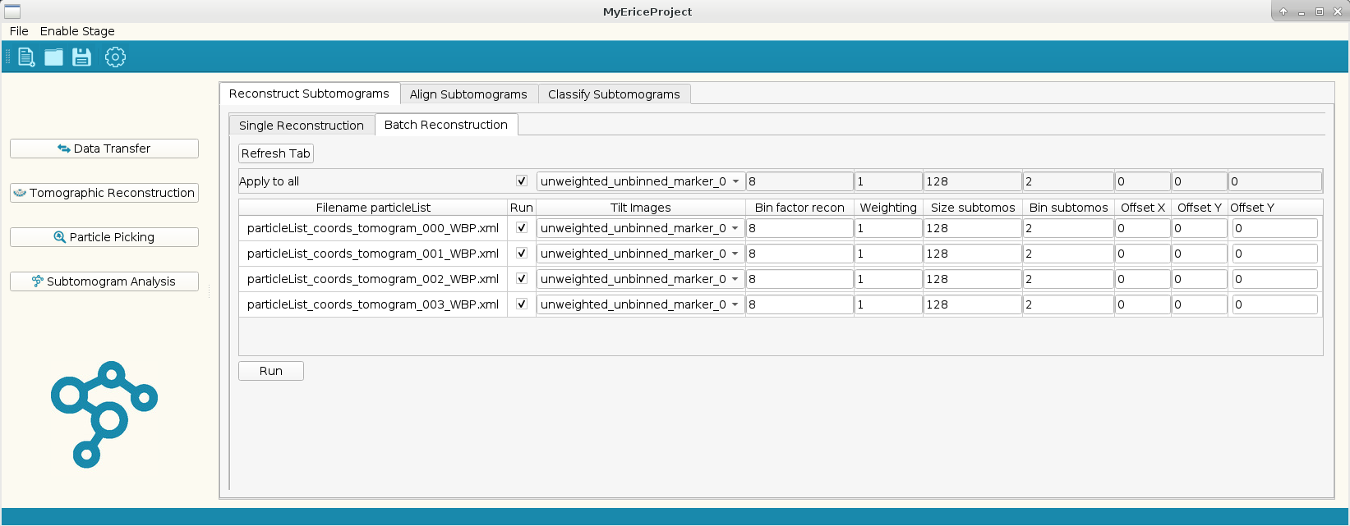

**Figure 17**. Batch reconstruction of subtomograms. The projections used for the reconstructions are in the third column. A pop-up window provides you with different options. Until recently, the folder name for uncorrected and CTF corrected aligned projections were the same – the last option refers to the CTF corrected one. In the present PyTomGUI this is changed to make distinction easier ;). *Bin factor recon* is the downsampling factor of the volume used for (manual) particle picking, in this case 8. *Weighting* is the weighting applied to the projections prior to reconstruction; ‘1’ is the weighting that accounts for the angular sampling, ‘-1’ the ramp-weighting and ‘0’ no weighting (if projections are already weighted).

## Subtomogram alignment

Alignment of subtomograms to a common coordinate system, which then allows meaningful averaging, relies on iterative algorithms. In PyTom, relatively simple quasi-expectation maximation approaches iteratively optimize the correlation of particles with an aligned average. In particular, the 3D rotational search is vast as three Euler angles need to be sampled. PyTom supports two flavors of iterative subtomogram alignment: Fast Rotational Matching (FRM) and real space alignment.

Real space alignment tends to be more accurate because it can be focused on specific features of the molecule of interest with a mask, but the orientation sampling takes much longer in real space. As a consequence, only a limited range of orientations can be sampled in a single iteration, decreasing the radius of converge compared to the FRM alignment. Thus, real space alignment is a good option if the approximate orientations of the particles are known.

To use real space alignment, choose the tab *Align Subtomograms* with the specification *GLocal* (Gold-standard Local alignment) (Figure 20). Required input are a *Particle List* (with good approximations of orientations, for example from template matching or initial FRM alignment), a *Mask* (spherical mask can also be created in GUI). Please general a mask of the sample dimension as your subtomograms (64 pixels), with radius of 25 pixels and a smooth factor of 4. An initial external *reference model* can be provided or the average from the particleList will be used. The generation of this average will take some time (>1 min).

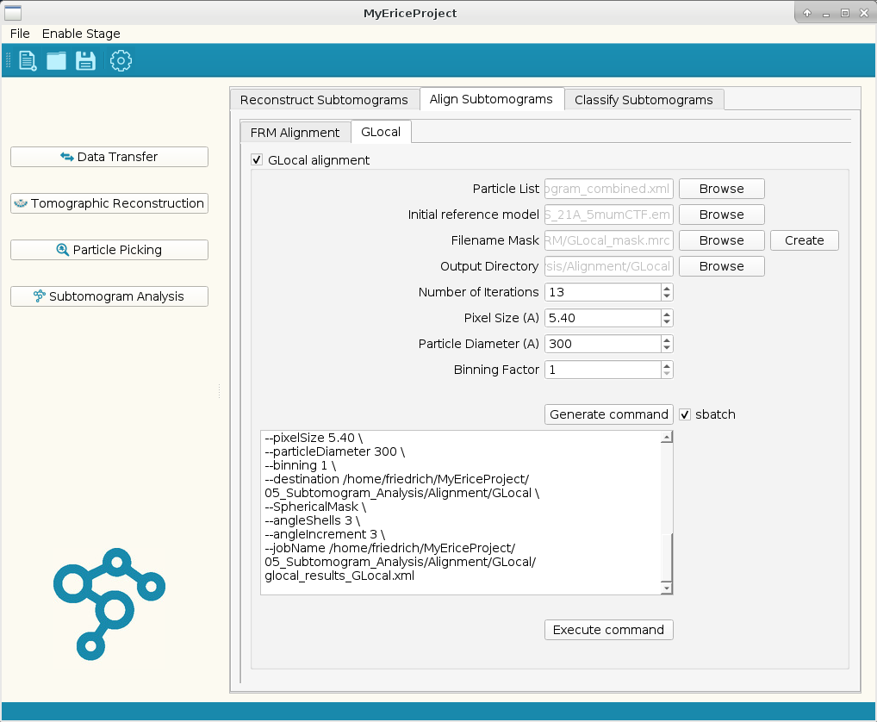

**Figure 20**. Real space alignment menu. The menu *generates* the *command* for the GLocal alignment. At this point the GUI still requires you to specify a reference file – if you do want to use the average created from the data from the beginning you can just delete the reference in the generated command (this ‘hack’ will soon be obsolete …).

Results of the GLocal subtomogram alignment will be stored in [myProject]/ 05_Subtomogram_Analysis/Alignment/GLocal/. For each iteration, the average, the average filtered to the resolution according to FSC and the respective particleList will be stored. When applied to the particles found by template matching the average rapidly converges (Figure 21).



**Figure 21**. Subtomogram average resulting from template matching. The resolution rapidly converges to ~20 A.

## Classification

Part of PyTom are two distinct classification approaches: Constrained Principal Component analysis-based classification (CPCA) and auto-focused classification. CPCA is designed to classify previously aligned subtomograms according to main features in a user-defined mask. Auto-focused classification aims to align subtomograms simultaneously with classification and to automatically focus the classification on the most variable parts of the data. In this tutorial we will not use CPCA.

### Autofocused-classification for outlier removal

Above CPCA classification requires accurately pre-aligned particles and typically prior knowledge on which feature to classify for. Auto-focused classification is an attempt to alleviate these requirements. The procedure continuously monitors the variance between the class averages, where the classification is focused on (hence the name: auto-focused). Class assignments are based on a voting procedure: pairwise comparisons are made for each investigated particle (i.e., the particle is compared to class 1 and 2, class 1 and 3, class 2 and 3, and so forth) and the particle is assigned to the class that has most ‘wins’ in these comparisons. You access this classification option through the tab *Auto Focus* in *Classify Subtomograms* (Figure 24).

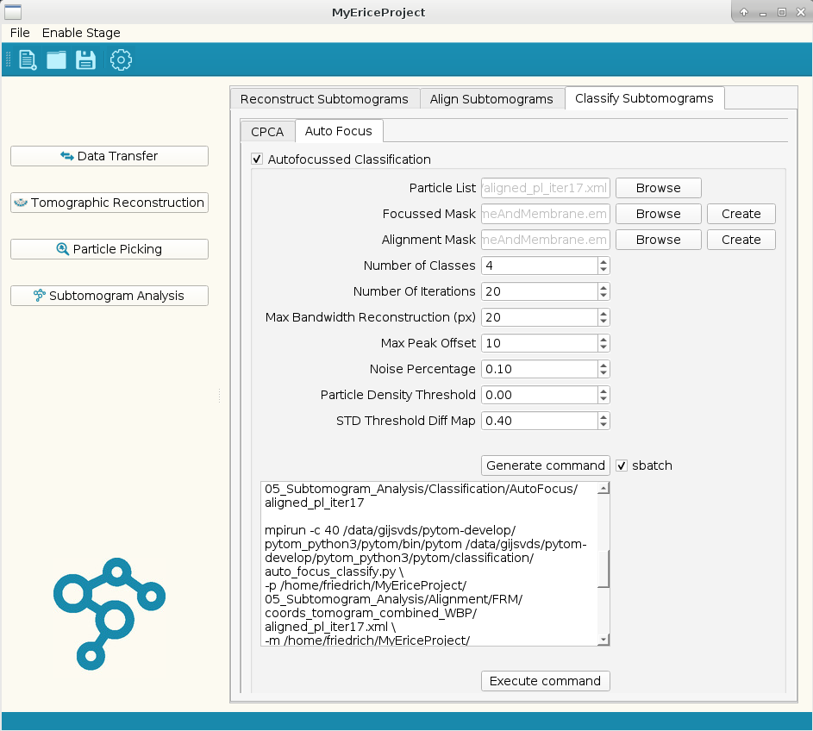

**Figure 24**. Auto-focused classification. Autofocused classification is performed on the specified *Particle List*. The *Focussed Mask* allows to restrict the classification area; for example, membranes can be flexible and you may want to exclude this area from the classification to rather focus on other structural features. The *Alignment Mask* is required for the subtomogram alignment at each classification iteration. The *Noise Percentage* is an estimation of particles that likely do not correspond to any meaningful class and should rather be assigned to a ‘junk’ basket (here 10%). The *STD Threshold Diff Map* determined the auto-focused mask: areas above this threshold are used for the classification (here 0.4 times the standard deviation). The Particle Density threshold focuses on particularly negative densities – typically classification targets densities that are present / absent in the classes at this resolution.

Please use the settings as defined in the screenshot. The noise percentage is the percentage of particles that are outliers. These particles will be discarded in the further steps. You can use the 3d viewer to evaluate the results. In ParticlePicking/Alter particlesList you can extract the respective classes from the output particle list.

### G-Local Alignment for unbinned subtomograms

After removing the outliers, you can redo the subtomogram reconstruction step, but now with a subtomogram binning factor of 1. Please use the particle list generated in the previous step.

Using the new subtomograms, one can align the subtomograms again, but now unbinned (regenerate the reference and mask). After this alignment your resolution should be less than 17 Å.



**Figure 22**. Subtomogram average resulting from unbinned subtomograms, after AutoFocus classification. The resolution rapidly converges to ~16 A.

### Limiting the range of tilt angles to improve the resolution.

In order to improve the resolution of the reconstruction we need to address the issue of sample deformation/deterioration during image collection. We do this by only using first 21 recorded images.

In the tilt alignment step in the tomogram reconstruction window, there is an option to limit the tilt angles for an alignment. Please limit your angles from -20 to 20 degrees. Now alter your particle list in the alter Particle List window, to have two wedge angles of 70 degrees. Save your particle list under a different name, extract the particles and rerun the alignment. The result of the alignment should now be approximately 12 Å.



**Figure 23**. Subtomogram average resulting from subtomograms with limited range of tilt angles (-20 deg to 20 deg). The resolution converges to ~12 A.

### Generation of tight mask for accurate resolution determination.

The current resolution of the model is an underestimation of the real resolution, because the mask is relatively large compared to the object. We are thus averaging a significant amount of noise. By creating a mask that is tighter to the object, this problem can be avoided. This does, however, create the danger to create a too tight mask, which leads to an overestimation of the resolution of the model.